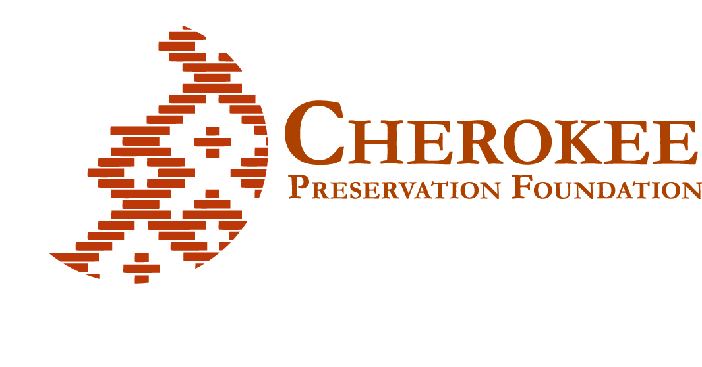
Preparing New Cherokee Leaders by Emphasizing Cultural Values

Established in 2000 as part of the Second Amendment to the Tribal-State Compact between the Eastern Band of Cherokee Indians (EBCI) and the state of North Carolina, the Cherokee Preservation Foundation’s (CPF) core mission is to improve the quality of life for the EBCI by addressing areas including leadership, cultural preservation, economic development, job creation and environmental sustainability.

In 2005, the CPF convened members of the community to help develop a continuum of leadership programs for tribal members from teens to adults. The purpose of the culture-based leadership programming is to help produce a selfless, giving generation, grounded in traditional Cherokee values, yet possesing the requisite skills for modern leadership. Over time, new leaders joined the ranks of those already serving as leaders in tribal government, the EBCI-owned casino, community organizations, local businesses and the CPF.

The Traditions of Cherokee Leadership
Two Cherokee traditions — the grand council and ga-du-gi — illustrate key elements of Cherokee leadership. In the Cherokee culture, leaders are people who simply do what needs to be done — they do not step to the forefront seeking recognition. This is the meaning of “selfless.” Grand councils were conducted for many generations, until the 1820s, to deliberate on important matters. At these councils, every Cherokee — from the youngest to the oldest — had the right to be heard. Leaders sought understanding and consensus.
Ga-du-gi, in the Cherokee language meaning “working together for a common goal,” is a Cherokee tradition in which community members help neighbors in need, such as cultivating the garden of a sick person or digging a grave for a family’s loved one. Members work to give back to their community, yet are modest about their many contributions.

The CPF is proud of its culture-based leadership programming and the values upheld by the Cherokee people.

Cherokee Values
During a community planning initiative, EBCI community members articulated the tribe’s cultural values:
- Spirituality, creating a bond among Cherokee people in good times and bad, and is a source of hope.
- Group harmony in community and kin relationships, and freely sharing and giving time, talent and treasures.
- Strong individual character, with integrity, honesty, perseverance, courage, respect, trust, honor and humility.
- Strong connection with the land and commitment to stewardship of the homelands of the Cherokee.
- Honoring the past, by knowing one’s ancestors, identifying with and belonging to the tribe, and living and preserving Cherokee culture.
- Educating the children by providing values- oriented education and recreation, and by being strong role models for them.
- Possessing a sense of humor, which can lighten pressure in serious situations and help people make good decisions.

Cherokee Leadership

The Right Path: A Program for Adults
The Right Path, “Du-yu dv-i,” program, provides unique leadership learning to tailor contemporary leadership development competencies from the wisdom of Cherokee ancestral cultural leadership. Right Path serves members of the Cherokee tribes of the Eastern Band, Cherokee Nation, and United Kituwah Band. The 12-month program works to bridge the past and present by incorporating programming that includes Cherokee language lessons, and introduction to cultural lifeways such as Cherokee clan customs, field trips to identify native plants, and visits to sacred sites like Kituwah and Cowee mounds. Curriculum includes use of the contemporary personality assessment tools.

Participants are selected through a nomination process with the final selection determined by the Right Path Advisory Council made up of community professionals and Right Path alumni. Participants’ employers support their attendance for two days each month, for 12 months. There are 20 alumni.

Coulter Regional Leadership Program
Coulter Regional Leadership Program was established in honor of Dr. Myron Coulter, Chancellor Emeritis at WCU, and Board Chair of the CPF. The purpose of the Coulter program is to connect people from the EBCI with their rural neighbors to together address challenges and pursue opportunities to benefit the region. The program pilot began on October 23, 2013, with a three-day retreat on the campus of Western Carolina University (WCU). The cohort represents Haywood, Jackson, Swain, Clay, Graham counties and the Qualla Boundary. Like the Right Path program, Coulter curriculum is focused on producing, “selfless leaders.”
Right Path and Coulter Regional leadership programs were created by the Cherokee Preservation Foundation and are being administered through Western Carolina University, Education Outreach Division.
For more information, contact:
Juanita Wilson
828.788.2579
jmwilson@wcu.edu.

Jones-Bowman Leadership Award Program:
A Program for College Undergraduates
In 2008, the CPF established the Jones-Bowman Leadership Award Program, which makes awards each year to undergraduate college students committed to developing their leadership capabilities. The program honors the memory and leadership of Principal Chief Leon Jones and Mr. James Bowman, members of the EBCI and founding members of the Board of Directors of Cherokee Preservation Foundation. Jones-Bowman Fellows receive funding to enable them to participate in individual leadership learning plans that include activities such as special academic enrichment and tutoring programs, U.S. and foreign travel, conferences, leadership development training, mentoring experiences and sponsored volunteer service.
For more information, contact:
Alicia Jacobs
828.497.5550
ajacobs@cpfdn.org

Youth Programming
In 2005, the CPF and the Cooperative Extension Service partnered to develop a cross- cultural eco-study program involving EARTH University in Costa Rica. To date, dozens of youth in the region, ages 14 through 17, have traveled to Costa Rica in the summer to visit other indigenous communities, learn the impressive lengths to which Costa Ricans go to create a sustainable environment, and broaden their experiences. The trips are a wonderful experience for the young travelers, helping them develop new skills and greater self-confidence. In learning about another culture and informing other Native communities about theirs, they develop a greater appreciation of their own culture and the need to preserve it for future generations.
For more information, contact:
Tammy Jackson
tammjack@nc-cherokee.com
828.554.6934

Cherokee Youth Council
The CPF helped establish the Cherokee Youth Council in 2006. Modeled after the Cherokee grand council, the Cherokee Youth Council allows Cherokee youth, grades 7 through 12, to be involved in addressing issues directly affecting them. It provides an atmosphere for youth to voice their opinions on issues that matter to them and create opportunities to develop leadership skills. The Cherokee Youth Council’s Go Green Team has mounted an impressive recycling education effort that has inspired the entire community. The Council is working on other issues, including teen pregnancy and cultural preservation, and has inspired the formation of youth councils in Swain, Graham Macon and Jackson counties that have also received CPF support. In addition, a newly-formed regional youth council includes representatives from all seven-county youth councils are working together on a collaborative project.
For more information, contact:
Skye Sampson
skykano@nc-cherokee.com
828.554.6934

Cherokee Day of Caring
In 2005, CPF teamed up with the EBCI tribal government and Harrah’s Cherokee Casino Resort to launch an annual event called the Cherokee Day of Caring. Based on the Cherokee tradition of ga-du-gi, during the daylong event held each May, several hundred members of the tribe of all ages help 10 families or individuals in particular need. They lend a hand with painting, yard clean up, gardening, or whatever help is required. The event includes the recognition of
10 Quiet Heroes who have served their communities selflessly, and a Good Neighbor Award to honor a non-EBCI member who provided service to
the community.
For more information, contact:
Deb Mintz
828.497.5550
DMintz@cpfdn.org

Lessons Learned May Be Helpful to Other Tribes
Other tribes face challenges similar to those on the Qualla Boundary that gave rise to the CPF’s leadership initiative. Our hope is that the steps we have taken and the lessons we have learned will be helpful to others in Indian Country.
For more information about the CPF’s culture-based leadership initiative, contact:
Bobby Raines
828.497.5550
Bobby.Raines@cpfdn.org

