Memo to: Qualla 2020 Committee Members

From: John Weiser
Ben Sherman

Date: March 31, 2014

Re: Notes from March 21st meeting

This memo presents the notes from the March 21st meeting of the Qualla 2020 Committee.

Meeting Attendees:
The meeting was attended by the following individuals from the Qualla 2020 Committee:

Chief Hicks
Bill Boyum
James Caldwell
Missy Crowe
Hope Huskey
Carla Jamison
Marie Junaluska
Amy Kaloneheskie
Ray Kinsland
Lisa Leatherman
Jason Lambert
Wanda Lawless
Kristy Long
Adele Madden
Skooter McCoy
Paxton Meyers
Charlene Owle
Morgan Owle-Crisp
Amy Parker
Forrest Parker
Brooks Robinson
Ray Rose
Jacob Reed
Russ Seagle
Bo Taylor
Reuban Teesatsateskie
John Tissue
Angie Votaw
Paula Brown Wojtkowski

Qualla 2020 overview
This was the second of six meetings for the Qualla 2020 Project. The committee reviewed the purpose and timing of the Qualla 2020.

The purpose of the Qualla 2020 Project is to diversify the Cherokee economy and reduce its risks so that it can better ensure the well-being of the Cherokee population into the future. In order to do this, the Qualla 2020 Project will seek to mitigate the dependence of the economy on gaming revenues, and to develop and expand businesses in ways that uphold the core values of the Cherokee people.

There will be four additional Committee meetings
- Wednesday, April 23, 9:00 am – 3:00 pm
- Wednesday, May 21, 9:00 am – 3:00 pm
- Friday, June 27, 9:00 am – 3:00 pm
- Tuesday, July 15, 9:00 am – 3:00 pm

Task teams will meet by phone between Committee meetings to develop detailed action plans for Committee review. At the final meeting in July, the Committee will choose action plans to recommend to EBCI Administration, EBCI Tribal Council and Cherokee Preservation Foundation.

Presentation on Qualla Boundary Economy and Cultural Tourism

Ben and John presented information on the Qualla Boundary economy, and on cultural tourism. To download the PowerPoint for this meeting, including these presentations, please click here.

A few of the key points from the presentations:
- The Qualla Boundary economy is heavily dependent on gaming revenues. This is both a source of strength, but also a risk factor for the future.
- Tourism revenues and traffic for the Western North Carolina region have been steady or growing over the past five years, but attendance at Unto These Hills and the Oconaluftee Indian Village have declined sharply during the same time period. This suggests the need for a new approach to cultural tourism on the Boundary.

Options for Increasing Tourism

The Committee then focused on options for increasing tourism, particularly cultural/heritage and nature-based tourism.

Skooter McCoy, Director of Destination Marketing for the EBCI, presented his department’s vision on how Cherokee could be transformed from a day-trip to an overnight destination, dramatically expanding visitation and revenue over the next decade.

Brand: The two greatest assets for transforming Cherokee tourism are:
- Cherokee culture
- Natural resources

Districts: Experience, education and entertainment are the keys to destination tourism. They are what brings tourists to a location, and keeps them coming back. Clearly defined districts can help attract and orient tourists.

Skooter described the vision for a coherent set of districts in Cherokee:
- Cultural – Unto These Hills and the Oconaluftee Indian Village are moved down from their current site onto what is now the Fairgrounds. Unto These Hills is set in an enclosed space rather than being open air. A fly fishing museum and the Chamber of Commerce are located where the Welcome Center is now, and additional retail is added in that area. This brings together multiple cultural and natural resource attractions in one compact area.
- Downtown: Base Camp of the Smokies – the downtown area shops are strongly encouraged to focus on providing equipment, clothing, supplies and tours focused on the natural resources in the Smokies, making downtown the “go-to” place for tourists interested in outdoor activities.
- Convention/Fairgrounds – the site of the former High School becomes the new fairgrounds and convention center. Arrangements with hotels in walking distance will enable the convention to guarantee blocks of rooms to convention visitors – key to the ability to host conventions.
- Wildlife – in the current site of the Oconaluftee Indian Village, the wildlife attraction is developed, using the existing walking trails and adding observation platforms to enable visitors to see animals in their native habitat. This also helps to address the problem of the negative publicity coming from PETA for the current treatment of bears in Cherokee.
- Saunooke Village – the existing Village is supported with additional signage and highlighted as an area for family fun and retail.
- Gaming – the area around the Casino remains as a gaming destination, with additional restaurants and amenities for the Casino visitor.
- Indoor Adventure Park – this is under consideration.
- Special Events District – this might be added in the future as well, or combined with the Convention/Fairgrounds.

This map provides a sketch of where the districts might be located in Cherokee.
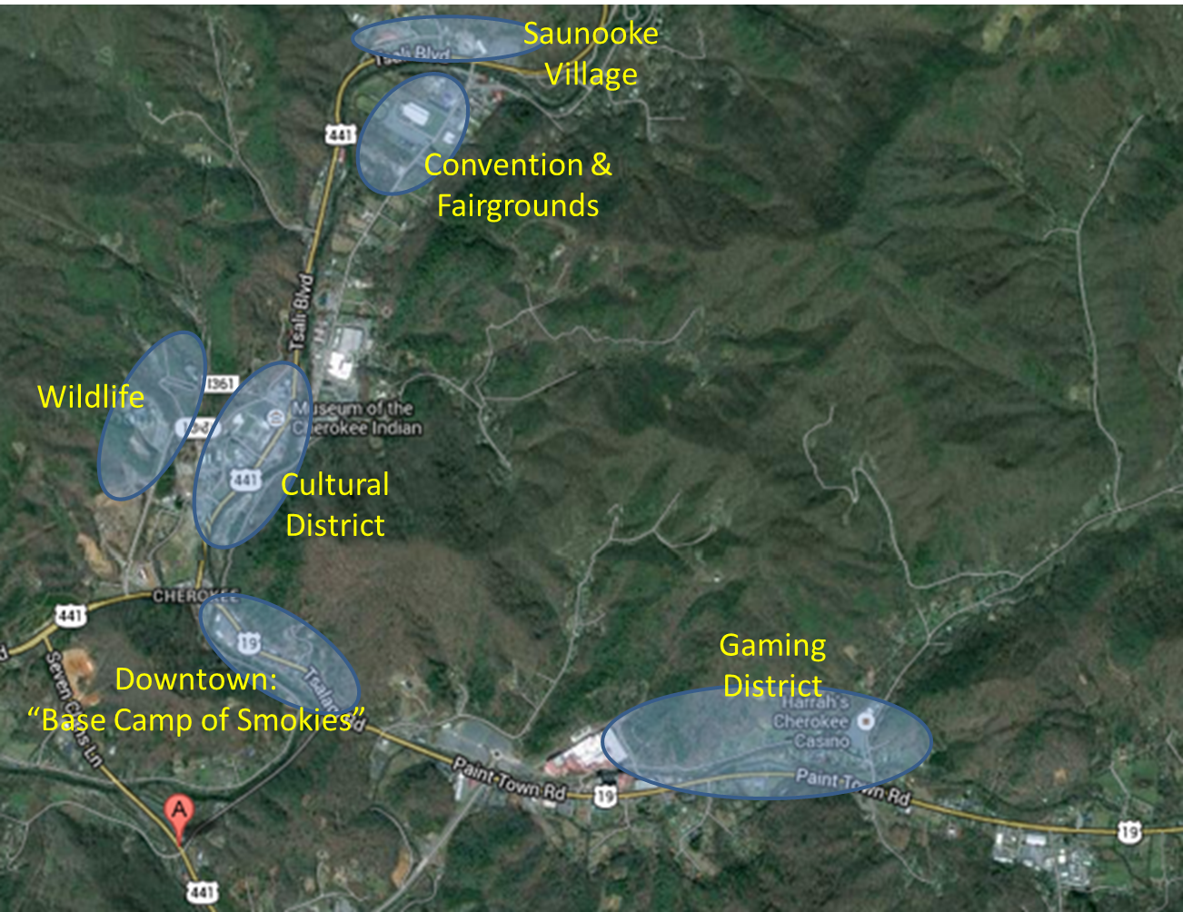
The Committee members overall felt that the concept of districts as described by Skooter was very attractive. It could both help to increase overnight visits, as well as draw in additional investment from outside the Boundary.

Creating the districts is a long-term endeavor, and will require considerable effort and funding. It will also be very important to connect with community members to help them see the big picture and get excited about the vision. There will be likely be many individuals who will be opposed to the process of creating districts in part because they are comfortable and familiar with the way that things are, and won’t be persuaded that the cost of moving many of the existing attractions will bring enough additional benefit to be worth the cost.

The community clubs are one way of engaging the community, but not the only way. A number of participants noted that community club meetings may be dominated by a few vocal and dissatisfied individuals, who don’t represent the overall opinion of the community. If you want to engage the community, it might be better to go to church socials and ball games.

Committee members noted under the current Tribal governance arrangements, the Tribal Council will be a key decision-maker in developing new attractions. It will be critical to create a process in which the Council buys in and feels ownership over the process.

Some committee members noted that recent Tribal Council concerns about investments in new attractions made them feel that it would be very difficult to get Council agreement to a plan with as many complexities and uncertainties as the goal of creating districts, and then to maintain that agreement over the next ten years as the plan is implemented piece by piece. They felt that it might be useful to consider the creation of a Tourism Development Authority, which would be given responsibility to implement the plan once the master vision was agreed to by the Council.

Participants also agreed that even when the districts are created, it will still be important to add multiple new attractions and upgrade existing ones. A rule of thumb is that travelers expect four hours of engaging activity for each hour of travel. In order to draw more people and have them stay overnight, Cherokee needs many more hours of engaging activities in the various districts.

Investments in New Attractions
The participants made the following observations about investments in potential new attractions and upgrading existing ones:
- The continued drop in attendance at the CHA attractions is very problematic, and it is time for a significant change. We cannot continue the current course.
- Unto These Hills needs a rain cover. The cost of rain-outs (which are clear) and the cost of those who stay away because it might rain (which is hard to measure) are too much for the show to bear. Unto These Hills probably also should probably run just three nights a week, and have alternative shows and events on the other three nights.
- When considering upgrading attractions, it is important to look at benefits versus the cost. There may be investments in existing attractions that will help to improve their attendance, but not enough to be worth the cost of the improvement.
- The marketing budget for Cherokee attractions is dwarfed by the budgets for Gatlinburg, Pigeon Forge, and Ripley’s. It may be necessary to increase the budget to achieve an increase in tourism visitation.
- Upgrading the fishing experience in or near downtown with a fishing pond may encourage families with children to stop and spend additional time downtown.
- A digital billboard would provide the ability to give consumers multiple messages during their travel time through the area.

Encouraging Private Investment
Committee members agreed that it was important to encourage private investment in tourism attractions and retail shops. The investment should not have to come solely from the Tribe. But committee members also noted the difficulties that have been encountered in attempting to bring in private investors for attractions. To effectively spur private investment, committee members felt that there needed to be a clear framework and process for reviewing and approving the investments. (This task will be taken up by the Real Estate task team.) There also needs to be support and momentum in Tribal Council, and support and momentum in the community.

The Tribe may also need to take a leadership role by investing in some of the tourism assets that it controls. Small business owners are waiting for the Tribe to invest before they commit to major investments themselves. Just as it did with the horseshoe area downtown, the Tribe may need to play a leadership role in encouraging investment in privately-owned stores and attractions.

Tourism Task Team Topics for In-Depth Review
The committee distilled the discussion above into three topics for in-depth review by the Tourism task team:
- Building agreement on the need for districts
- Strategies for re-invigorating CHA attractions
- Cross-selling and marketing Cherokee attractions

The Tourism task team can refine these topics, and can add additional topics for review as well. The goal for the task team review is to develop an action plan to move forward on these topics. The following is a summary of the committee discussion of each of these topics.

Building agreement on the need for districts
- Engage Tribal Council and community in setting and sharing vision
  - Develop compelling visual rendering and goals
  - Explain to community members “why is this important to you?”
  - Reach out to community members, including youth, elders, and business owners
    - In person at community club meetings, church socials, sporting events, events at the Fairgrounds
    - Through direct mail
    - Through a web site, Facebook page, and social media
- Build from existing plans and data
  - A number of master planning studies already highlight the need for districts
- Create an institutional and policy framework that will enable the Tribe to move from vision to implementation steadily over a ten-year period
  - Council formally adopts an overall vision for the creation of districts
  - Council creates an entity (“tribal tourism authority”) which is responsible for attracting and encouraging investment, setting priorities, and implementing the Council’s vision over time
  - Council also clarifies and streamlines the process for bringing new business investment into tourism attractions

Strategies for re-invigorating CHA attractions
The task team should consider a range of actions that might be taken to pull the attendance for the CHA attractions out of its current decline:
- Move the Oconaluftee Indian Village down from its current site onto Route 441.
  - Make the Village more visible from the road
  - Encourage cross-visiting from the Museum to the Village
- Continue to upgrade the Oconaluftee Indian Village experience
  - iPad tour
  - Crafts and re-enactments
  - Experiential events
  - Overnight stays and camps
  - Activities keyed to Museum exhibits
- Revamp the Outdoor Theater
  - Add a rain cover
  - Add technology and excitement to the show
  - Bring in additional shows and acts
- Deepen the current market research to better understand the “mind of the customer”
  - Try to understand the customer at the point of decision
    - What do our current customers like and want more of?
    - What do visitors who don’t come to Cherokee want – and can we find a segment of those who could be persuaded that Cherokee can provide what they want?

Cross-selling and marketing Cherokee attractions
The committee members noted that the web sites for Cherokee attractions now permit visitors to order tickets for CHA, the Museum, and the Fairgrounds, to purchase a fishing permit, and to find hotel rooms all on sites that are linked. This provides an excellent platform for cross-selling. Additional aspects that the task team is encouraged to consider:
- Explore how kiosks that CHA has can be deployed around town to sell tickets to attractions, purchase a fishing permit, pick a tee time, etc.
- Develop a system for using excess capacity at Drama, Village and Museum to create “value-added” packages for fishing, gaming and shopping
  - “Buy a fishing permit, and for $10 more, add on a visit to Unto These Hills – an $22.40 value”, etc.
- Explore methods for using e-commerce techniques to increase sales across all attractions

Framework for private investment
The committee members noted that clarifying the framework for private investment will be critically important in attracting new investment for tourism attractions. This task has been taken on by the Real Estate task team. This includes:
- Clarify the leasing process and the rules
  - Lease length
  - Bonding
  - Appraisal
  - Approval
- Update and clarify the Code so that the process of setting up a business is clear and consistent
- Clarify taxation issues
- Clarify commercial code issues

Small Business Task Team Report-Out

Ray Rose provided a PowerPoint summarizing the recommended focus and activities for the Small Business task team. Key points from the presentation:

- Top Down or Bottoms up Approach?
  - In the past we have often discussed what businesses we think would be “good” in Cherokee. In fact we were expressing our own desires for businesses that met our needs or preferences. This is a top down approach
  - We need a bottoms up approach
  - A bottoms up approach would work to advance to process of creating a business environment (a foundation)that meets the needs of and is desirable to as many businesses as possible
- A Basic Approach
- Establish a baseline description of a desirable/optimal small business environment
- Complete research necessary to map the small business environment in Cherokee
- Identify gaps/constraints between Cherokee environment and baseline
- Prioritize the challenges and attack the problem
- After That?
  - Create incentives to come to Cherokee
  - Develop the resources and avenues to connect with potential small businesses locally, regionally and beyond
  - Start, gain momentum, and sustain the effort

The meeting participants agreed that developing a baseline description of a desirable/optimal small business environment was an important starting point for the work on small business. They also noted that expanding the small business sector in Cherokee had three components: helping new businesses start, helping existing small businesses to grow, and attracting small businesses to the Boundary.

The participants made the following points about helping to expand small business:
- Make it easier to understand the process and rules for starting a business on the Boundary (this ties into the work being done by the Real Estate task force)
- Clarify the tax regime – what is subject to state tax, what is subject to Tribal levy
- Ensure that the state’s commercial code mirrors the UCC
- Work with Sequoyah Fund and others to increase the amount of expansion financing available
- Expand the level of market knowledge and make it more available
- Develop greater clarity about what triggers a NEPA review – and whether the Tribe can take actions that reduce the cost of NEPA reviews for individual businesses by spreading it over a number of businesses
- Encourage business-to-business support and networking
- Develop additional perks for small business owners, such as affordable housing and lease program incentive

Knowledge Industry Task Team Report-Out

The Knowledge Industry will focus on two inter-related issues:
- Expanding Knowledge Industry businesses and workforce. This would include both supporting local entrepreneurs and attracting new knowledge businesses. It would involve promoting the expansion of training and educational opportunities in technology. It also would look at the marketing required to counteract the perception that Western North Carolina is so rural and backwards that it is not a place where knowledge industries can succeed.
- Expanding broadband and communications infrastructure. The task team will primarily look at this through the lens of business expansion: what investments in the expansion of broadband and communications would be help local businesses to thrive, particularly home-based entrepreneurs?

Participants in the meeting noted that the knowledge industry covers a very wide range of businesses, from small home-based businesses using the Internet to sell crafts, to call centers and data centers.

Real Estate Task Team Report-Out

The Real Estate task team’s goal is to make recommendations to support real estate development on the Boundary. It is interested in encouraging private investment on the Boundary.

Issues that the committee is interested in addressing:
- Leasing – title to the land, lease bond, process (leases have to go before Council), appraisal, assessment (comparables)
- Financing issues regarding leases on trust land
- Uniform Commercial Code and taxation issues
- Tribal role in real estate development

The committee will provide insights and suggestions about how these issues might best be addressed by the Tribe and other entities.

The team will not focus on properties off the Boundary, except to the extent that they have a bearing on real estate development on the Boundary.

