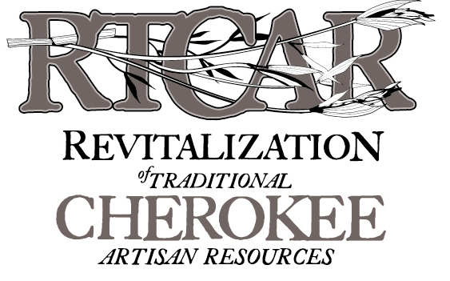

FALL 2024 GRANT CYCLE



**Grant Work Plan** *(use a separate page for each grant year)*

Organization:       Person completing this plan:

Project Title:       Project duration     *

* *(Mo/Yr to Mo/Yr – must begin after funding is approved)*

**Please note: The Grant Work Plan is your primary contract with the Cherokee Preservation Foundation/RTCAR. It informs us of what you expect to accomplish (Outcomes); the steps you will take to reach your goal(s) and when you will finish those (Milestones); and how much must be achieved to gauge the project a success (Measurements). This will inform the Final Grant Report, which provides us with the means to evaluate your level of success based on the projections from your original plan.**

|  |  |  |
| --- | --- | --- |
| 1. **– OUTCOMES:** What results are you seeking to achieve? List up to three **measureable** Outcomes for your project. What will be the impact as a result of this project? | **2 – MILESTONES:** Clearly define key milestones and expected dates for achieving them. Milestones are key steps/events needed to complete the project. | **3 – MEASUREMENTS:**  What quantifiable data will you use to track the Outcomes of this project, such as an amount or percentage? How will you know when success is achieved? List one to three measurements for each outcome. |
| **Outcome A:** | **Milestone (date to be achieved):**    **Milestone (date to be achieved):** | **Measurement 1:**    **Measurement 2:**    **Measurement 3:** |
| **Outcome B:** | **Milestone (date to be achieved):**    **Milestone (date to be achieved):** | **Measurement 1:**    **Measurement 2:**    **Measurement 3:** |
| **Outcome C:** | **Milestone (date to be achieved):**    **Milestone (date to be achieved):** | **Measurement 1:**    **Measurement 2:**    **Measurement 3:** |

**Grant Work Plan** *(use a separate page for each grant year)* ***– EXAMPLE WORK PLAN***

Organization: _____________________________ Person completing plan: __________________________________

Project Title: ______________________________ Project duration: _________________________________________

*(Mo/Yr to Mo/Yr – must begin after funding is approved)*

**Please note: The Grant Work Plan is your primary contract with the Cherokee Preservation Foundation/RTCAR. It informs us of what you expect to accomplish (Outcomes); the steps you will take to reach your goal(s) and when you will finish those (Milestones); and how much must be achieved to gauge the project a success (Measurements). This will inform the Final Grant Report, which provides us with the means to evaluate your level of success based on the projections from your original plan.**

|  |  |  |
| --- | --- | --- |
| **– OUTCOMES:** What results are you seeking to achieve? List up to three **measureable** Outcomes for your project. What will be the impact as a result of this project? | **2 – MILESTONES:** Clearly define key milestones and expected dates for achieving them. Milestones are key steps/events needed to complete the project. | **3 – MEASUREMENTS:**  What quantifiable data will you use to track the outcomes of this project, such as an amount or percentage? How will you know when success is achieved? List one to three measurements for each outcome. |
| **Outcome A:**  Reduce energy consumption by Tribal Government. | **Milestone (date to be achieved):**   1. Research and implement programs offered by the Tribe’s electricity provider (6/1/2012) 2. Develop an electricity efficiency training workshop for tribal employees (8/1/2012) 3. Complete training workshops for all tribal employees (4/1/2013) | **Measurement 1:**  $5,000 will be saved by switching to the cost saving and electricity efficiency programs offered  **Measurement 2:**  The Tribe’s overall consumption of kwh will be reduced by 5% in contrast with the records from 2011. |
| **Outcome B:** | **Milestone (date to be achieved):** | **Measurement 1:**  **Measurement 2:**  **Measurement 3:** |
| **Outcome C:** | **Milestone (date to be achieved):** | **Measurement 1:**  **Measurement 2:**  **Measurement 3:** |